Welcome to Ibestad municipality
The municipality consists of the two islands of Andørja and Rolla and has about 1400 inhabitants distributed on an area of approx. 240 km2.
The municipality- center is Hamnvik on Rolla.
The islands are tied together with an underwater tunnel; Ibestad tunnel, and has mainland connection by bridge from Andørja over Mjøsundet.
In addition, there is a fast ferry service from Engenes to Harstad and Tromsø, and a car ferry between Sørrollnes and Harstad.
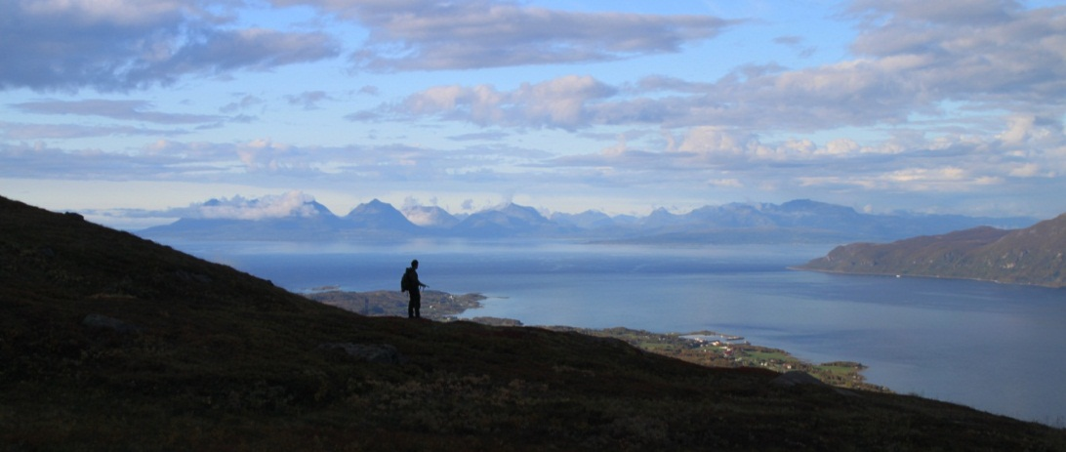
Small game hunting at Rolla
The municipality is an eldorado for people seeking out in nature, with many options for recreation, hiking and skiing. The islands have good conditions for fishing in freshwater and in the sea, and for hunting enthusiasts there is possibility of small and big game hunting.

Topography
The topography of the two islands is quite diverse. At Andørja there are many mountains and peaks, while there are the many water and ponds that have given the island Rolla its character. The concentration of high mountains, streams and water within a small area of approx. 240 km2 are some of the things that makes Rolla and Andørja so special.
Ibestad has a mild climate and a lush vegetation.
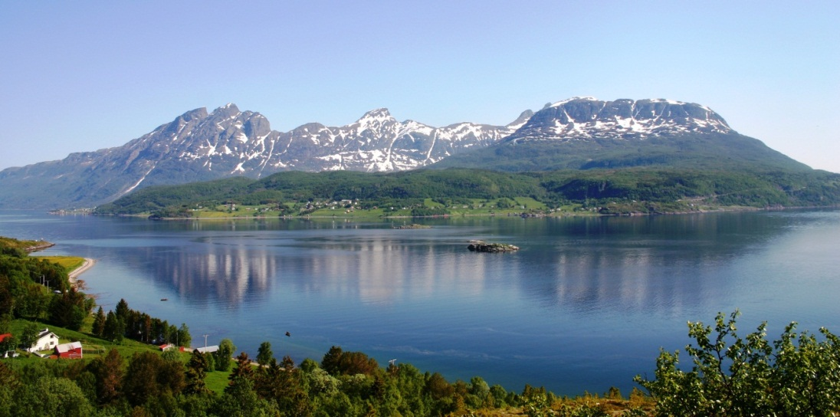
The strait Bygda with the mountain range of «Dronninga»(The Queen) at Andørja

History
Ibestad has a long history. The first signs of settlement are from the older Stone Age: approx. 8000 year old tools found at Sørrollnes. The rock carvings on Vik are approx. 6500 years old. The area has also had activity in younger Stone Age, Bronze Age and Iron Age. The settlements from the Iron Age include, among other things, the long house "The boat" and several graves; both tumuli and flat ground graves.
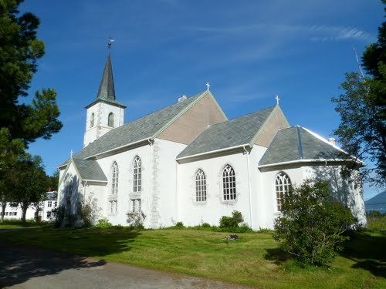
Sami settlement is also a part of the municipality's history and at Rolla more than 70 old housefoundations have been registered at Fjellhøgda by Sandvatnet. Ibestad as church site probably goes back to the 13th century. The old stone church on Ibestad was demolished in 1880, and the present church was completed in 1881.
Ibestad church
When the church was restored in 1967, a sarcophagus was found under the floor that could have been chopped out in the 1200s or 1300s. It has a wheel cross as a relief motif. This motive later became the coat of arms for the municipality of Ibestad.

Culture and Sports
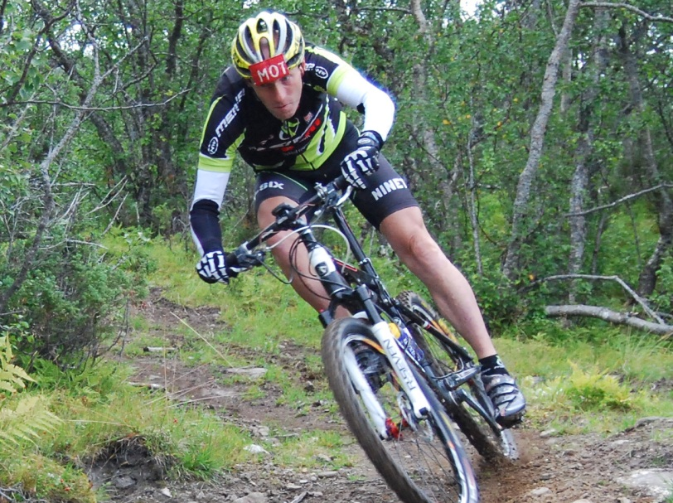
Ibestad have a rich cultural life with many teams and associations, and an active sports community with wide diversity. Ibestad is also a host for the Tour de Andørja Cycling Tour in the summer and the TDA Freeride Challenge, a freeride skiing-competition in winter (www.letour.no).
Mountain biking at Ånstad

Andørja
One theory is the name Andørja comes from Norse. “And” meaning “against”, and “yrja” which means gravel or stone. This can refer to the waves that hit the mountains.
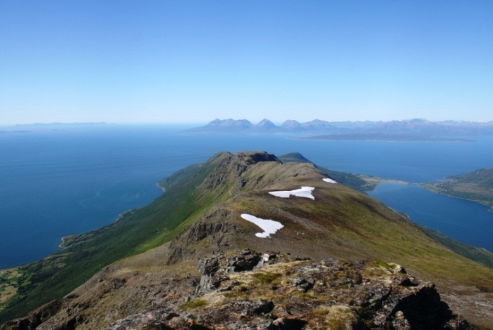
The island is considered to be the most mountainous island in Northern Europe. There are 20 peaks at Andørja of more than 1000 meters above sea level. The tallest of these is Langlitinden with its 1277 meters. Below the top on the northeast side of this top lies the glacier Blåisen.
«The roof of Andørja»
Straumbotn, an 8 km long threshold fjord that intersects between the high mountains of the island with a strong tidal flow where it meets the rest of the sea is also characteristic of the island.

Summit trips:
Stakken:
Starting point, Ånstad. Follow the road inwards the valley and get off it at Brubergan. Then follow the mountain bike trail and path to Stilleva. Furthermore, route on map via Måsan and up on the Innerstakken. Most people turn back here. Alternatively, you can cross the Storskaret which is “airy” to the Ytterstakken and down along a somewhat steep part of Ytteraksla.
Alternatively starting point at Igeland or Seglsteinen.
Time: approx. 3 hours to the top.
Hike requires pretty good physical shape.

Snøtinden:
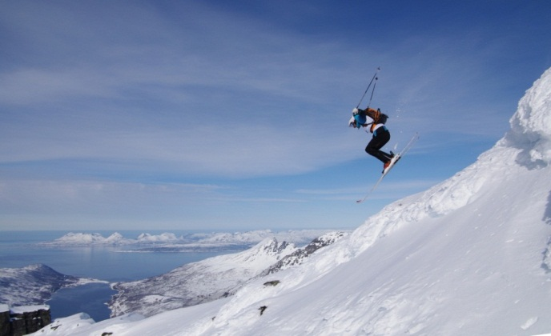
Starting point, Ånstad.
Follow the same route as Stakken to Stilleva. Then follow the marked route via Snøfjellvatnet and further up to the top. Steep climb from Stilleva and up to Snøfjellvatnet. From Snøfjellvatnet and up to the top there is quite a lot of scree.
Freeride from Snøtinden
Time: approx. 3.5t to the top
Somewhat difficult trip, requires good physical shape.

Langlitinden:
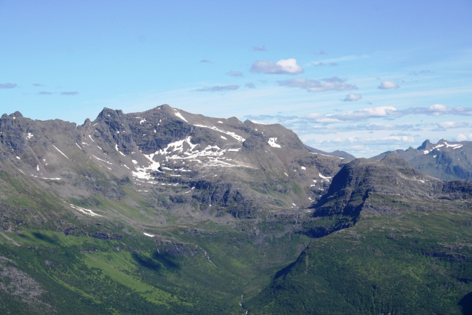
Starting point at Pollen Recreation Area in Straumbotn.
Langlitinden
Follow the marked path in the direction of Bjørndalen and follow this via Døsjen. Alternatively, follow the stream on the right side into the valley to Innerholvatnet. Marked route further. From the height above Innerholvatnet and up to the top there is scree.
Time: 3-4h to the top
Somewhat difficult trip requires good physical shape.
Take great care when at the top, free fall on rear side.

Family-friendly trips
Vasskarura og Vasskarvannet:
One theory states that Vasskarura was formed 10-11000 years ago.
During the last ice age, Troms with Andørja and Vasskardalen was covered with thick ice. As the ice melted, the pressure on the earth's crust relieved. This caused the crust to rise. There were shakes and earthquakes, with subsequent crashes. One thinks that the blocks probably fell on the ice that lay in the valley bottom of the Vasskardalen at the end of the Ice Age. The movement of the ice makes it impossible for one to say that all the stones are from Vasskartinden, but that it might also came from other nearby mountain areas, perhaps all the way to Trollan. Steinura is relatively large, and many of the blocks have a diameter of more than 20 meters. Vasskarura is a wonderful place for children and adults on exploring in trolly caves, on walks or on climbing among big boulders.
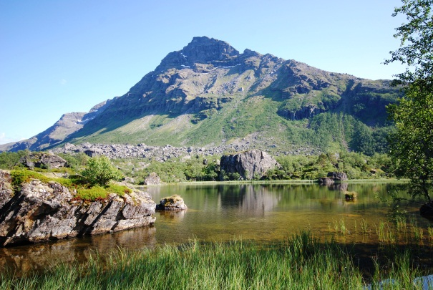
Vasskartinden, Vasskarura og Vasskarvatnet.
Pollen:
At the inner end of Straumbotn lies the outdoor area of Pollen. Because Straumbotn is threshold fjord, there is less change in the water in the fjord, which means that on hot summer days it is nice to take the trip here for a bath, grilling and camping!

Laupstadstranda:
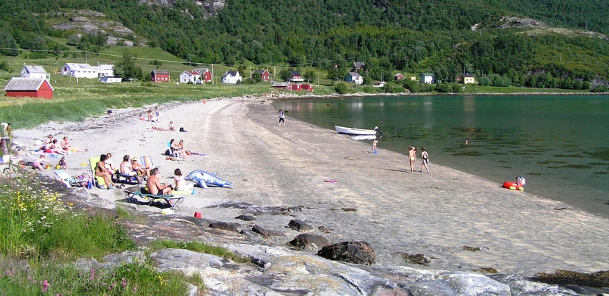
Laupstad Beach was voted to be the most beautiful beach in Troms a few years ago! The beach is located right by the road Fv132 (Andørjaveien) at Laupstad. There is both barbecue area and toilet on site.

Laupstad beach

Ånstadbotn:
Starting point for the trip is at Brekkabakken by the former school in Ånstad. Follow the forest-road to the bottom of the valley, or take the small bridge at Brubergan and follow the road / mountain bike trail to Kvantebotn and up to Ånstadbotn where there is a box with a book you can write your name in, and a campfire place.
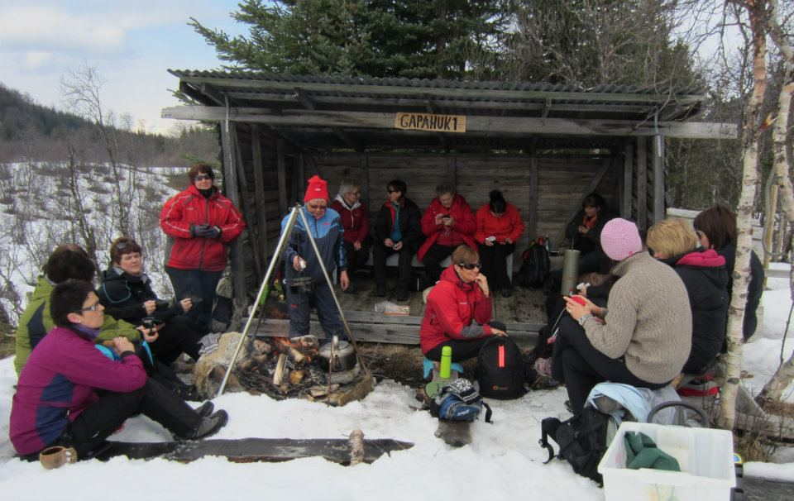
Nice family trip both summer and winter. The area is also widely used for skiing winter and Easter.
Coffee at Ånstadbotn for the ladies
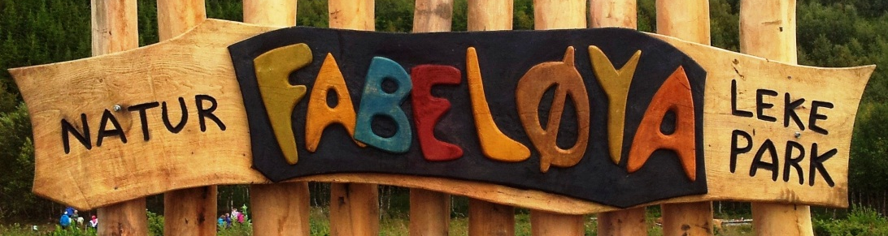
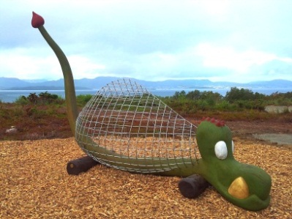
Fabeløya naturlekepark
At Sørrollnes at Rolla you will find Fabeløya Nature-playground!
Here you can climb, balance, play and have fun! You can also make a fire and grill in the bonfire huts.

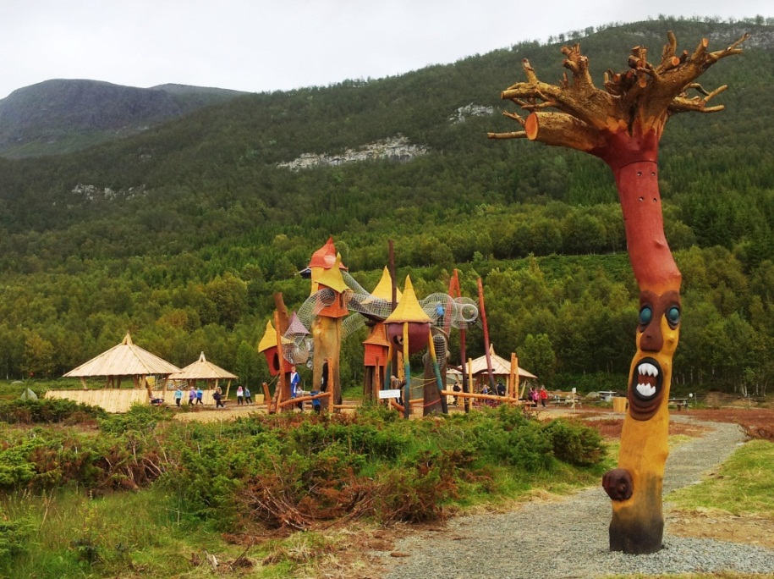

Grillhytter, Drangens Drømmetårn & Skogtrollet
The park is designed after the theme of fairytales and fable animals. A fable animal is said to be weird animals, birds and human-like creatures that belong in mythology and fairytales. They certainly do not exist in our real nature.
We want you to take on your "fable eyes" when you come here. Maybe you can forget the stress of your everyday life for a while ...?
For more information, please visit our webpages.
www.ibestad.kommune.no
www.naturlekepark.no eller www.fabeloya.no

Rolla
It is claimed that Rolla is the most watery island in Norway in terms of its areal. There are between 30 and 40 lakes on the island. In many of these lakes there are fish like trout and char. There are also 3 beautiful mountains at Rolla: Sula, Drangen and Rolla.
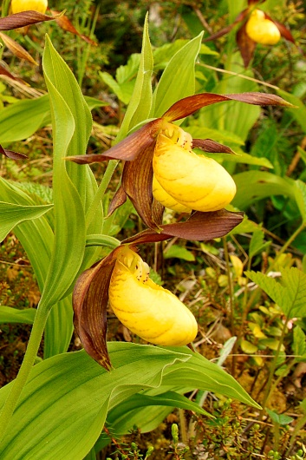
On the island of Rolla there are three areas protected by the Nature Conservation Act: Dyngeneset, Store Tømmervik and Lomtjønnmyran. If you go outdoors you can experience a special peculiarity. Of the 36 known wild type of orchids registered in Norway, 16 are registered on this island. This is an unusually large number within such a limited area because orchids place special requirements for the habitat. Several of the species found on Rolløya require lime in bedrock and nutritious soil. Most of them therefore have their main distribution on the island's south and west side, in conjunction with the marble veins that extend from Sørrollnes to Tømmervika. Here we also find the Nordic region's largest prey of lime birch forest.
Marisko
Marisko is the most eye-catching of the orchids, and it is the largest orchid flower. It is tempting to pick or dig it up, but the plant is protected by law.

Summit trips
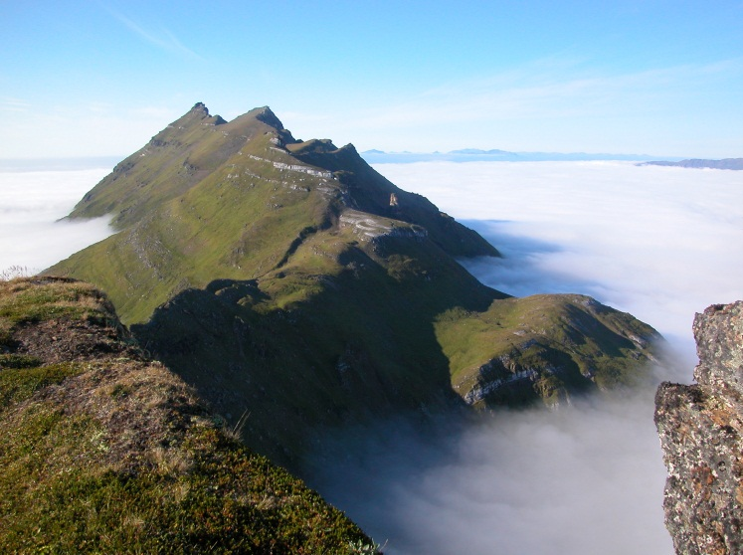
Sula:
Start from Partenat Breivoll. Follow road 200m from Rv 848 (Parking), take the forest road to the left through the gate and follow it almost to Fjellmyra, then take the path to the left up to Vedjan. Follow a tractor road to the right up to the forest limit 400 meters above sea. From here there is a marked trail to the top at 848 meters.
Drangen above the fog, view from Sula
Tid: 4 hours round trip.
Hike requires pretty good physical shape.

Drangen:
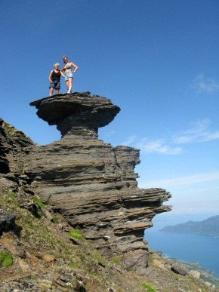
To the Drangen there are marked route options; from Nord-Forså and from Kobbetjønna 1,5 km north of Hamnvik. Alt. 1. Start from Nord-Forså. Follow the road to Mevatnet. Marked path to Sulvatnet and Drangen starts 30 m above the bridge by Litjevatnet. Alt. 2. Start from Kobbetjønna. Follow the road past the MC-track. From here follow the path until it meets road to Ibestadvatnet. From Ibestadvatnet there is a marked route to Stappedalen and further on to Doktorsteinan in Rundtinden, further on to Kjelan where the path meets the marked trail from Nord-Forså and follows this to the top.
Kannesteinen
There are two alternatives the last meters to the top. The first goes up a steep rocky joint. The second goes further north and around to the top of 1022 moh. This is the simplest path.
Both routes are approx. 17 km round trip
Medium to heavy trip that requires good shape.
Time: 8h round trip.

Rolla:
Start from the turning point at Sørrollnes. Follow the road to the lookout point at Ramnfløya 325m above sea level. From here, there is a marked trail around Storheia and up to Brustindvatnet 618 m.a.s.l. Further marking past Rollvatnet to Storvarden on Rolla 926 m.a.s.l.
Time: 6 h round trip.
Medium to heavy trip, requires good physical shape.

Family-friendly trips
Dyngeneset:
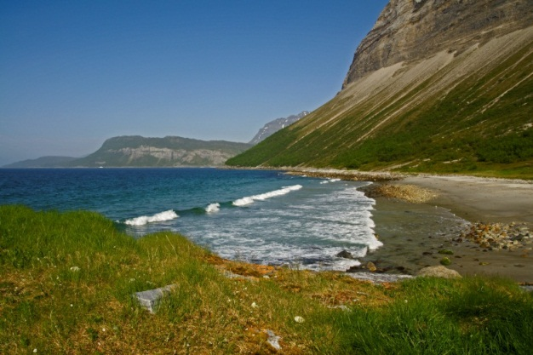
Start from Sørrollnes. Folllow marked trail over Hammaren to Omnsand and on to Dyngenesvika with its fine sandy beach. On Omnsand lies the cave Omnen. This cave is located approximately at the middle of the pebble beach Omnsand between Foldneset and Dyngenesvika.
The cave lies a little above the high-water level in a limestone mountain and is probably formed by washout from the sea when it was on a higher level. It has a rounded opening approx. 4 m wide, 2 m high and goes tapered approx. 6 - 7 m into the mountain.
Dyngenesvika
10 km round trip.
Tømmervika:
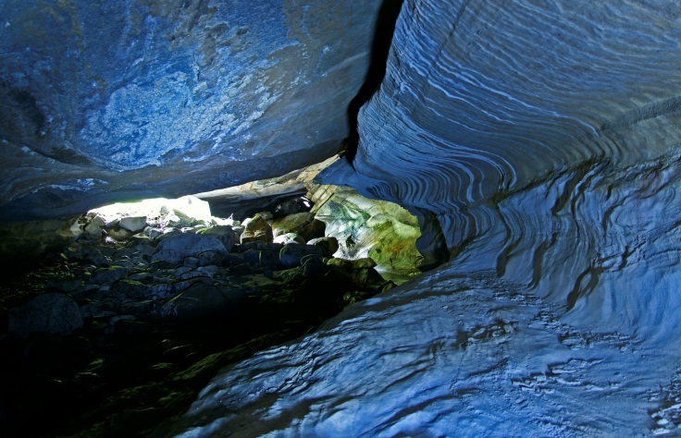
Start from Fugleberg north of Rollnes. Follow the marked path or the road to Mølnhusvatnet. From here, follow marked path over Mulheia down to Tømmervika. When you are here it is a matter of course to see the beautiful Tømmervikgrotta(cave). The cave is approx. 200m up from the sea in Stor-Tømmervika and is approx. 30 meters long with beautiful lime deposits in the ceilings and along the walls. Follow the river to a small red cabin, take a small trail towards the river 10-15 meters and you are at the lower entrance. The river from Tømmervikvatnet flows through the cave which is probably made from large water flow from ice melting for approx. 10,000 years ago. The cave has three entrances, the lower to the sea is a bit difficult to drift while the two upper entrances are straightforward. To walk through the cave, both because of the ceilings (1 to 1.8 m) and the water that flows through, one must bring a flashlight.
9 km roundtrip.
Tømmervikgrotta

Remember that Dyngeneset and Tømmervika are nature reserves.

Kobbetjønna - Parten:
Start at Kobbetjønna. Follow the road up to the MC track, follow the marked path (steep climb) up to the top of Ibestadheia and on to Fjellmyra. From here down to Parten along the road.
Tour length 7 km.

Forså – Dyrstad:
Start at forest road to Mevatnet from Forså. Follow this road to the lake, then walk along Mevatnet / Sandvatnet to the north end of the lake, from here on, follow the road down to Dyrstad.
Tour length approx. 15 km.

Parten – Skog:
Start from Parten. Turn left through the gate, follow road almost to Fjellmyra and further outskirts road over Vedjan, Sandrø and Kuklipa down to Skog. Follow Rv 848 to the starting point.
Tour length approx. 10 km.

